PMS-ES Annotated User’s Guide

Updated October 13, 2017

Table of Contents

Introduction 4

Entities 4

Modules Summary 4

Location of Data 6

Some Important Things a PMS-ES Programmer Should Know 7

User Roles 7

Project Hierarchy 7

Relationship of Program to Project / Phase 7

Administration by System Users 8

Administration by PMS-ES Developers 9

File Exchange 10

Add / Modify / Browse Folders and Files 10

Adding a Folder 12

Adding Files 16

File Search 20

User Access Search 22

Keyword search from a text box on top right of the banner 23

Report – Folder Listing 24

Report – No Access 25

Library 26

Introduction 26

Library Content 26

Overall PMS-ES User Characteristics 26

Visibility of Library Content 26

User Access to Library Content 27

Browsing 29

Search and Edit 31

Edit Collection Properties 32

Attach Document 34

Guidelines when developing new Library 35

Here are some old database notes 36

Library Search Screen 38

Library View Document Details Screen and Open/Download File 39

Library Home Screen 40

Library Browse Screen 41

Library Add New Document Screen and Upload File 42

Library New Version Screen and Upload File 43

Calendar 44

Announcements 45

Project Team Maintenance 46

Central Management Console 47

InfoView (AdHoc Reporting) 48

# Introduction

This document contains guidelines for a programmer maintaining or updating the PMS-ES system. PMS-ES stands for Project Management System – Enterprise System.

This document describes the User interface (UI) for PMS-ES, but also includes references useful for a PMS-ES programmer, to such items as databases, database tables, database fields, and their meanings. Hence, we use “Annotated” in the document title.

PMS-ES is a web-based system for managing Programs, like PMS385, which is a program for a Hull.

There are several customized versions of PMS-ES, for different customers.

Each customer has a set of users. Users get access to PMS-ES by logging into the system with a unique username and password. Usernames and passwords are assigned by ……..

Only logged-in users can do actions within PM-SES.

## Entities

These are the major entities with which PMS-ES is concerned. Expanded definitions appear in the glossary.

User

Program

Project/Phase

Ship

Platform

Hull

Within each module writeup, there are descriptions of other entities tracked within PMS-ES. For example, File Exchange manages Folders and Files. Library manages Folders, Files, and Collections.

## Modules Summary

Major modules of the PMS-ES system are

* Administration By System Users
* Administration by PMS-ES Developers
* File Exchange – File Sharing
* Library – Library Document Sharing
* DRL – Document Review?
* Calendar
* Announcements
* Project Team Maintenance
* Central Management Console
* InfoView (AdHoc Reporting)

## Location of Data

PMS-ES is an umbrella system, which presents a common User Interface (UI) to present its data along with data from various other databases, one for each project/phase. Data for PMS-ES is in one database, and for some PMS-ES modules, project/phase information is in a separate database. For example, if a project/phase uses only File Exchange, there is NO separate database for the project/phase, since File Exchange data resides only in PMS-ES. Library data also resides only in PMS-ES. Similarly, PMS-ES contains the list of users, the list of programs, the list of project/phases, the list of roles, and the list of assignments of roles to programs and project/phases, for those items which it is managing.

On the other hand, DRL data for a project/phase IS in a separate database. For example, there is a PMS385 database containing project/phase data about hull PMS385.

## Some Important Things a PMS-ES Programmer Should Know

IN this document, we are using ALL CAPS to designate database table and field names. Clearly this information is part of the “annotated” type of information, which is intended for PMS-ES programmers.

### User Roles

Users have roles. If a user has a particular role, he is allowed to see certain portions of the PMS-ES User Interface (UI), and to perform certain actions from within the UI.

**The very unusual name for the table containing the list of roles is PG-LU. The key is PG_ID. The PG-LU.TITLE fields contain values like ‘CONFIGURATION MANAGER’, ‘COST PROPOSAL ACCESS’,’LIBRARIAN’, ‘LIBRARY USER’, etc. A programmer must always take care to equate PG_ID to “ROLE_ID” – a fictitious field name, when looking at table structures, queries and CF code in the PMS-ES system.**

### Project Hierarchy

There is a **project** hierarchy reflected in PMSESPROJ_LU. A project hierarchy is completely independent of a folder hierarchy, such as appears in the Library and FileExchange modules. **In a break from our normal naming conventions, the key field for PMSESPROJ_LU is PROJID**.

PMSESPROJ_LU.PARENTPROJID reflects the project hierarchy.

### Relationship of Program to Project / Phase

A program is at the highest level. A program can contain a number of projects. There is a hierarchy of projects, as described above. The unusual name for the table containing the list of Projects and Phases is PROJSETTINGS. The key field is PROJSETTINGSID.

A PROJSETTINGS record is related to a project through PROJSETTINGS.PROJID. Remember that the PROJSETTINGS record puts the document in the project hierarchy, as just discussed. A programmer can think of a PROJSETTINGSID as pointing to a program, or to a project, or to a phase of a project, depending on the characteristics of the PMSESPROJ_LU record to which is points via PROJSETTINGSID.PROJID. if PMSESPROJ_LU.PARENTPROJID is null, then the PROJSETTINGSID is pointing to a program. Otherwise, the PROJSETTINGSID is pointing to a project, or to a phase of a program or a phase of a project.

# Administration by System Users

# Administration by PMS-ES Developers

# File Exchange

The main screens are File Search, and User Access Search, and Add/Modify/Browse. All uploading of files is done from the Add/Modify/Browse screen. Downloading is done from any of the screens, but clicking on the name of a file.

File Search allows you to find a file based on file name, and Create Date.

User Access Search lets you find a file based on file name, a selected user, and Access Date.

Add/ Modify / Browse has more functionality, including s Folder/File Search, Add Folder, and Upload Documents.

## Add / Modify / Browse Folders and Files

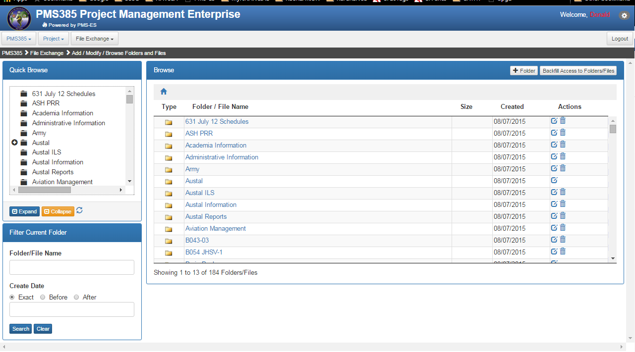

The pane on the top left shows **Folders**. Folders can be partial searched by entering a partial match and clicking OK.

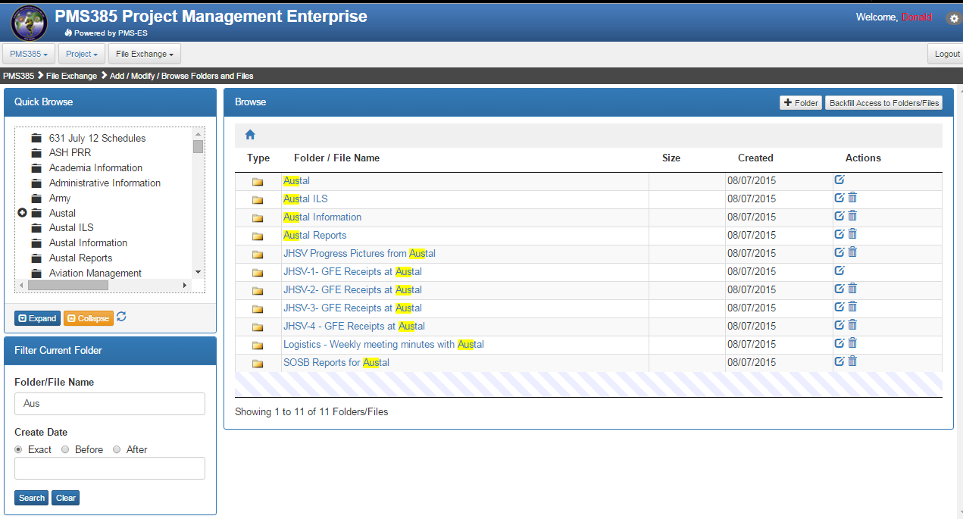

## Adding a Folder

Folders are added by clicking + Folder. The folder is inserted at the point where you are in the folder navigation. For example, we have navigated within PMS385 to Brain Book, JHSV, and see two folders.

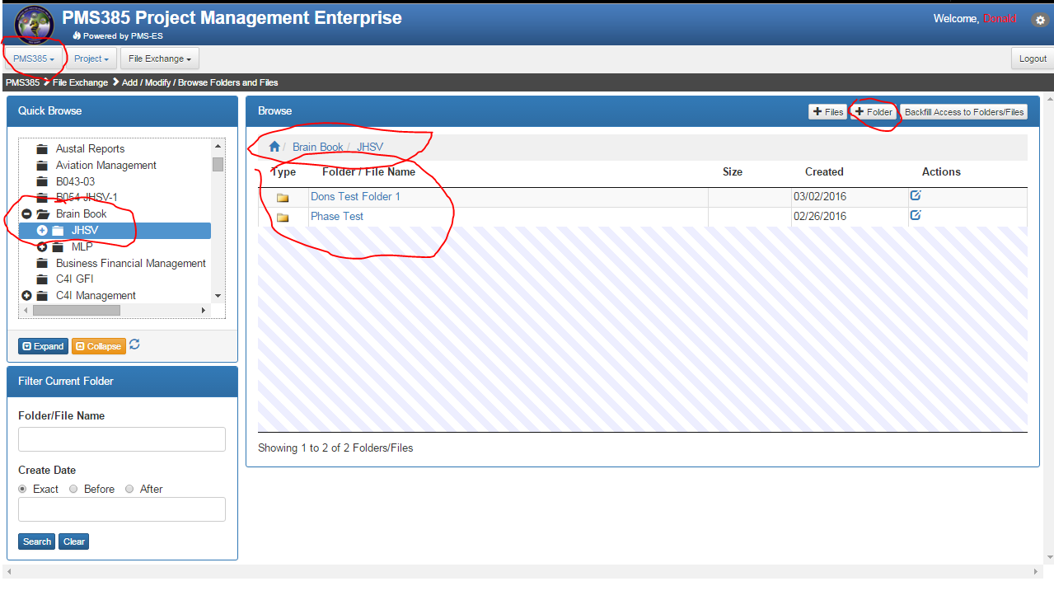

We click **+Folder** and have a chance to enter the name for the new folder. The new folder will appear within the Current Folder show near the top of the popup.

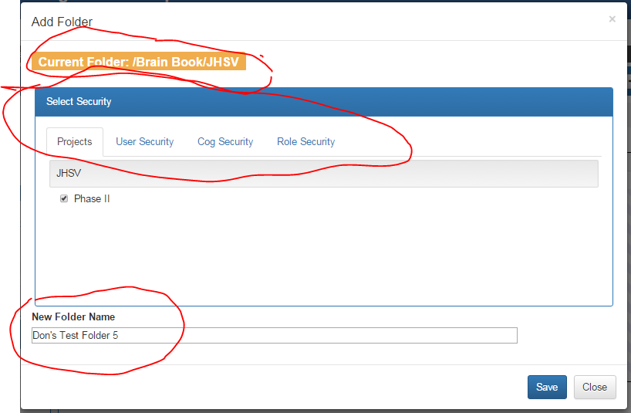

For example, you might be in PMS385 (Not PMS385/JHSV). Then, you might navigate to a particular folder, where permission has been granted to JHSV, Phase II. Phase II has a PROJSETTINGS record for this program/project (JHSV). There is a PROJSETTINGS record for each program, project, and phase.

There are four types of security within PMS-ES used by File Exchange, as shown in the tabs on the popup above.

The Projects that appear are all those projects to which the logged-in has access. Within that list, the projects that are checked are those projects which have been given permission to the folder.

In the above picture, you can see JHSV (the project/phase), which contains Phase II, which is a project/phase to which I have access based on my login. It is checked because a user that has access to Phase II can access this folder.

The User Security tab shows users that are associated with the project/phase (PROJSETTINGS record) we are logged into. Again, among the list of users associated with the PROJSETTINGS, a user is checked if he has permission for the folder.

The Cog Security tab shows a list of cog codes that are assigned to ANY users associated with the program/project. “COG Code” is a Cognizance Code, which generally is a point in an organization where responsibility lies. Any user can have exactly one COG code for a particular program/project (PROJSETTINGS record). In PMS-ES jargon, a cog code is synonymous with an activity code. In this screen, from the list of all the cog codes available, a cog code is checked if it has access to the Folder. Note that ***this list of COG codes does not depend on the security settings of the logged in user***.

The Role Security tab shows a list of roles assigned to the project/phase. This assignment is made in the PMS-ES Administration module, in the SysSec Tab. Within the list of roles, a role is checked if it has access to the folder. Note that ***this list of roles does not depend on the security settings of the logged in user***.

Similarly, the User Security tab shows all the users assigned to the project/phase. For the new folder, the check boxes are pre-populated based on the User Security from the current folder. The same is true for Cog Security and Role Security. Note that ***this list of users does not depend on the security settings of the logged in user***.

After you modify the security for the new folder, click Save creates the new folder with the selected permissions.

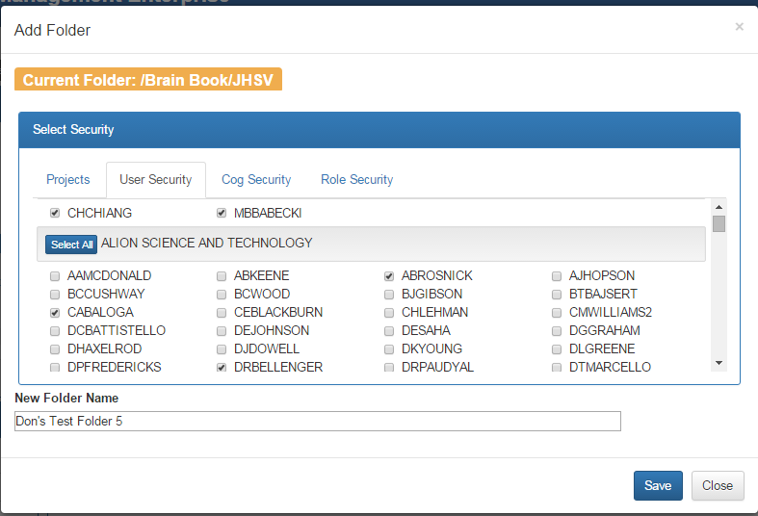

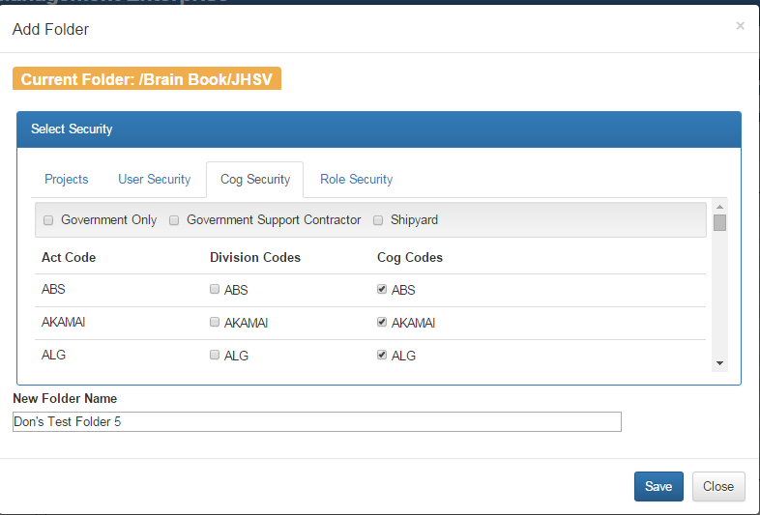

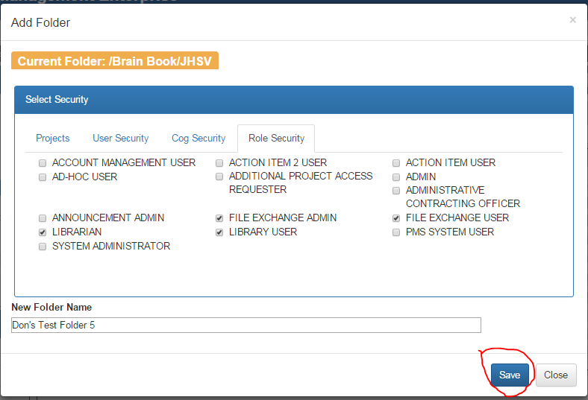

Note that the new folder is at the top of the list of folders within the current folder. The Edit icon at the right side of the “Don’s Test Folder 5” line allows you to edit the folder name and security selections. The Delete icon allows you to delete the folder. Only empty folders can be deleted.

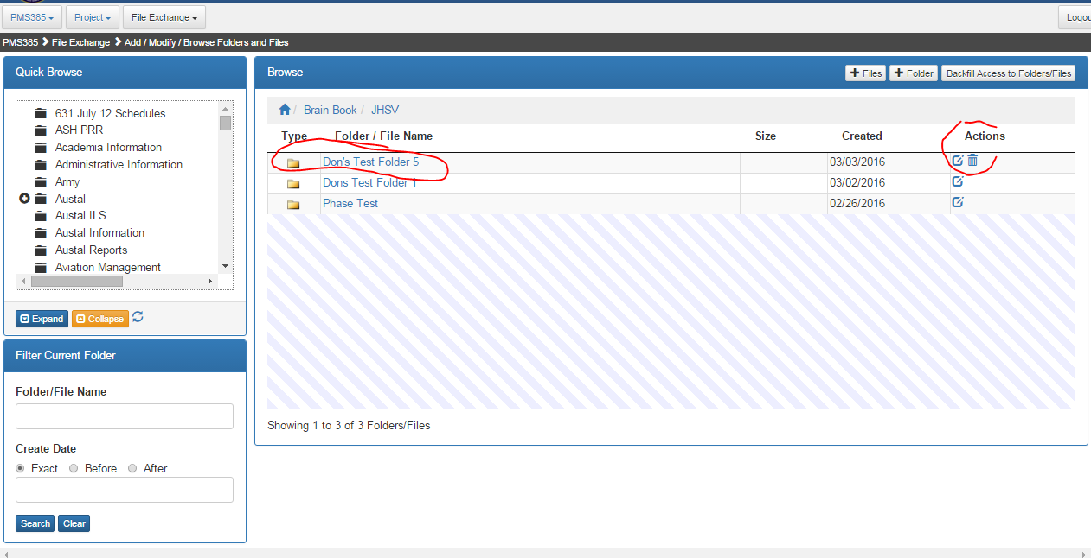

## Adding Files

Continuing with our example, we have navigated into the new folder, and clicked +Files. Note that more than one file can be added at a time, so long as all the new files are to share the Security Selections. Initially, the security selections are set to those of the folder. You may also elect whether to send notification emails to ………. about this upload. The list of people to email is maintained by …….. in the ………… area of the PMS-ES application.

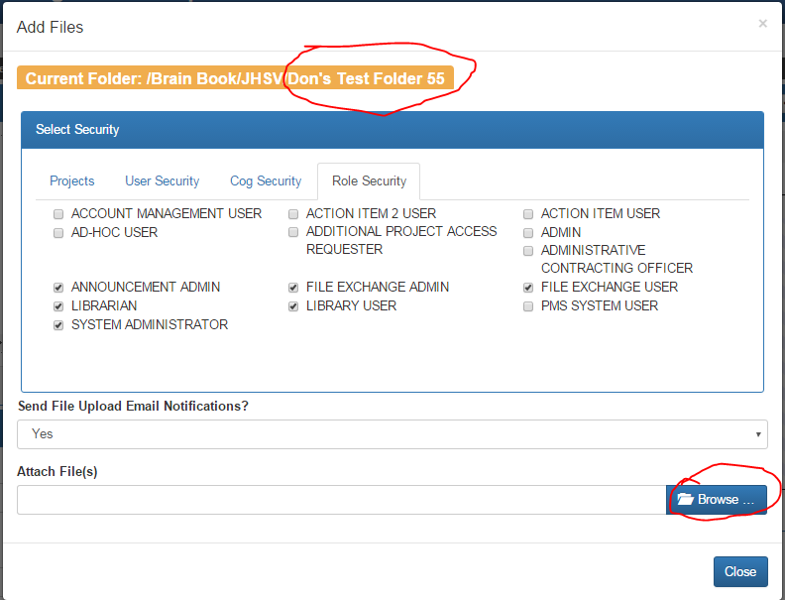

Clicking Browse allows you to select multiple files to upload, using the standard Windows ctrl-click for each file to upload.

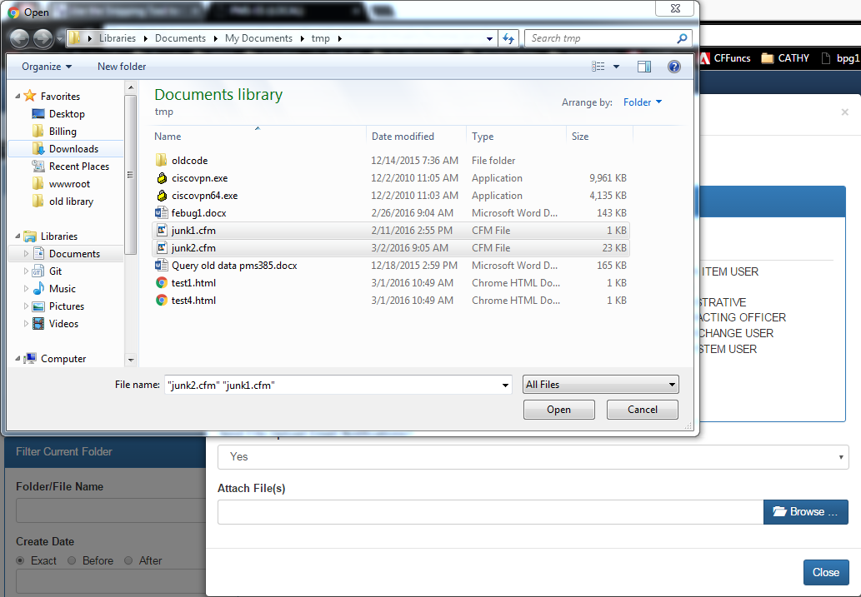

Clicking Open returns you to the Add Files popup, and allows you to browse for more files, remove one or more files from the Attach Files panel, or finally initiate the upload of the files. If you Close without Upload, this effectively cancels this Add Files session.

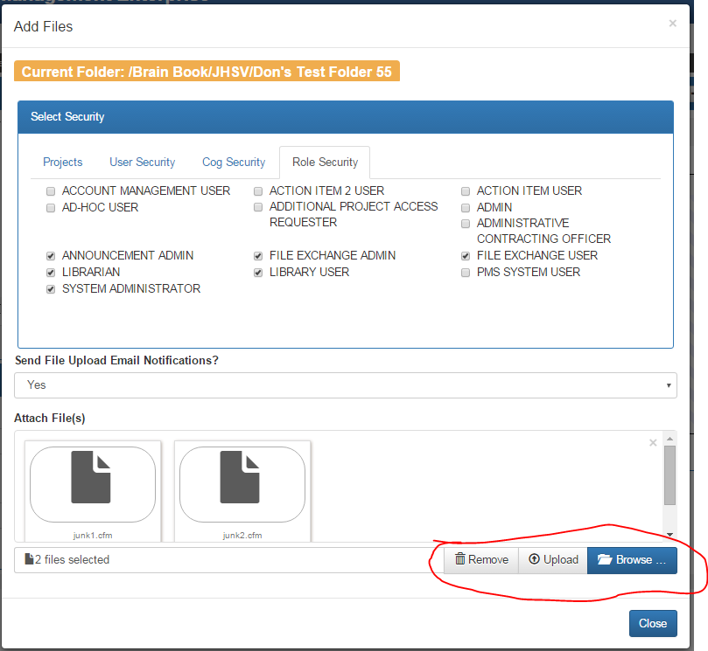

On the other hand, clicking Upload Uploads the files. You can either upload some more files, possibly with different permissions, into this same folder, or Close the Add Files popup. Here is the result after the upload, showing the new files. Note that in our screenshot, the breadcrumb trail erroneously is not showing Brain Book / JHSV/ Don’s Test Folder 5.

Clicking the Edit icon on a file allows you to change the permissions on the selected file. You cannot rename it. Clicking the Delete icon allows you to delete the document from the database.

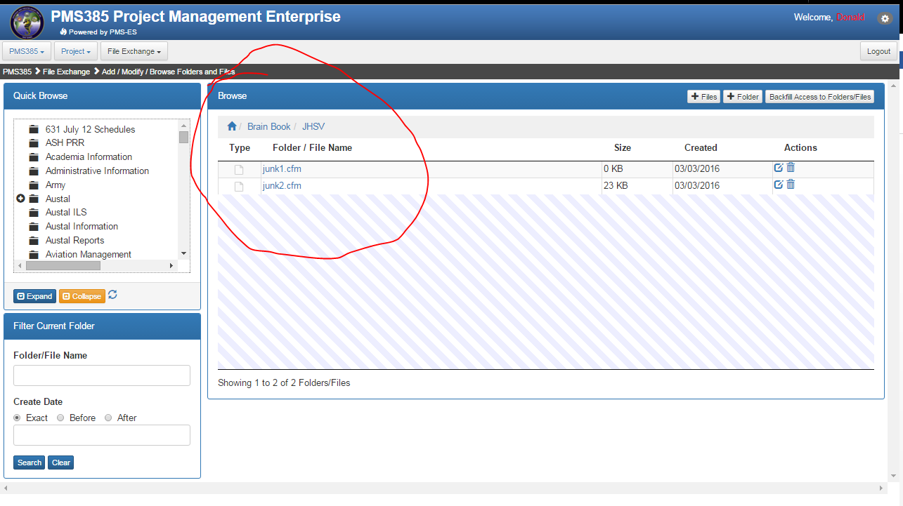

## File Search

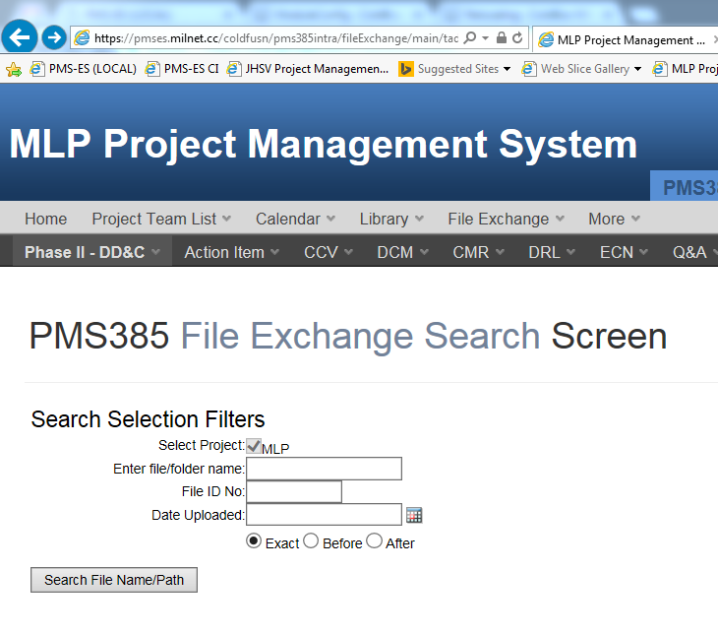

This is search filename/path

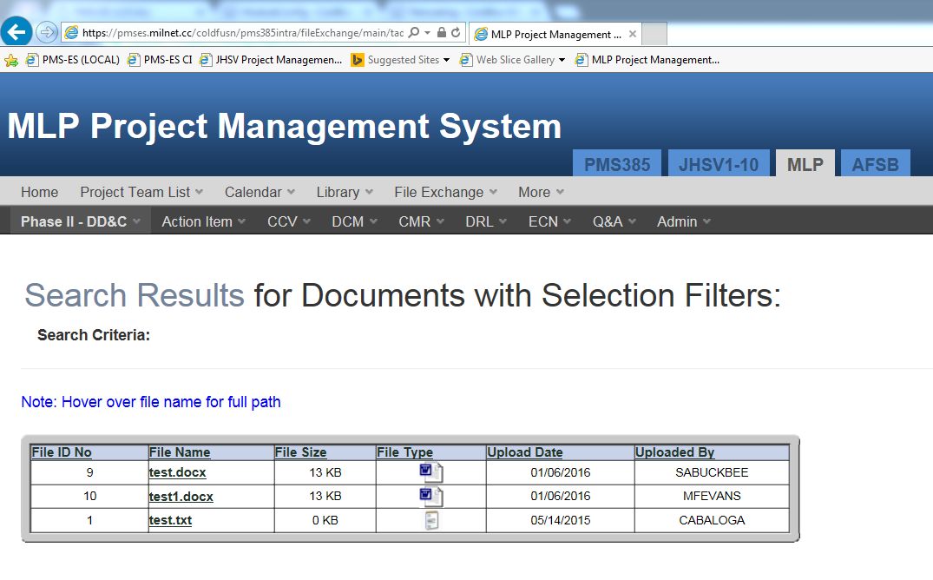

## User Access Search

This just adds the name of the person who accessed the file

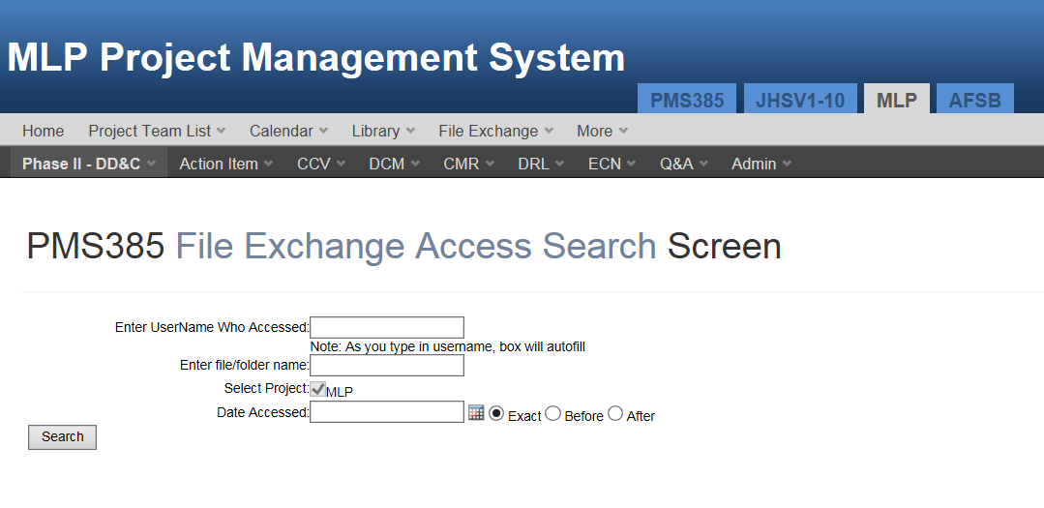

## Keyword search from a text box on top right of the banner

Note tabs and check boxes for include full text search, and Rile Exchange Module, and Library Module.

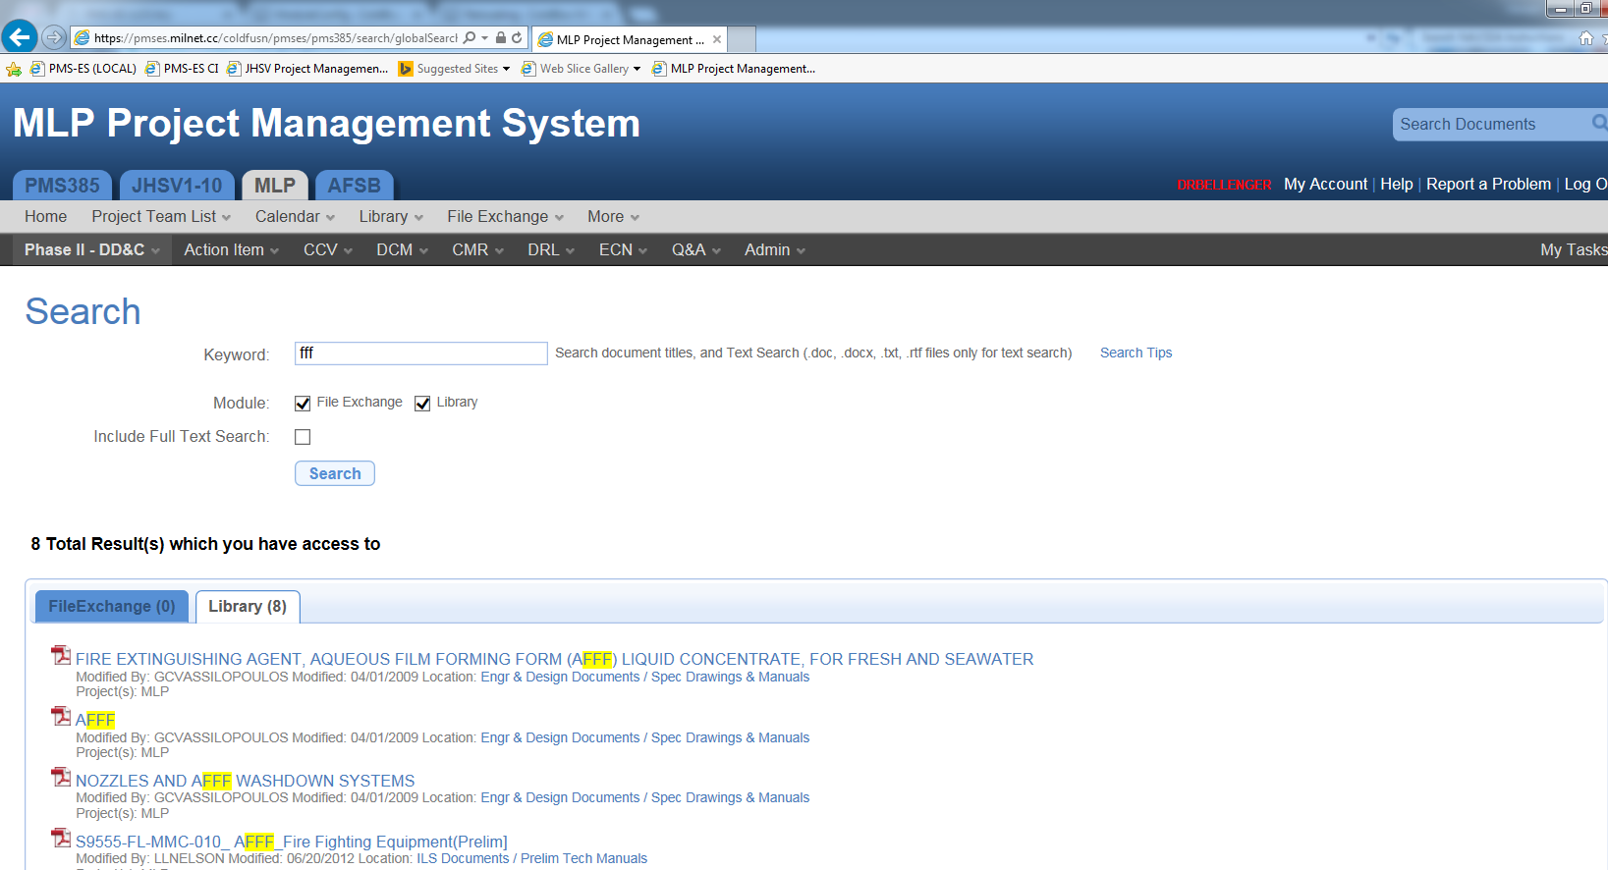

Here is the popup under search tips.

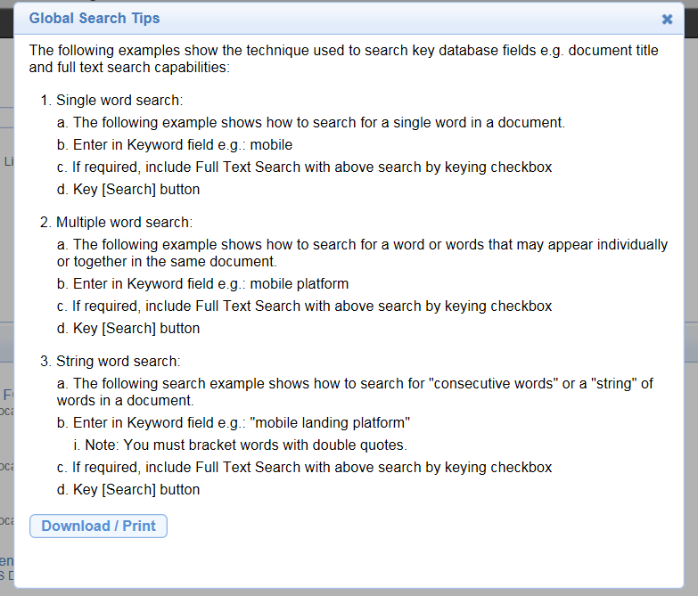

## Report – Folder Listing

The folder listing report is an excel spreadsheet.

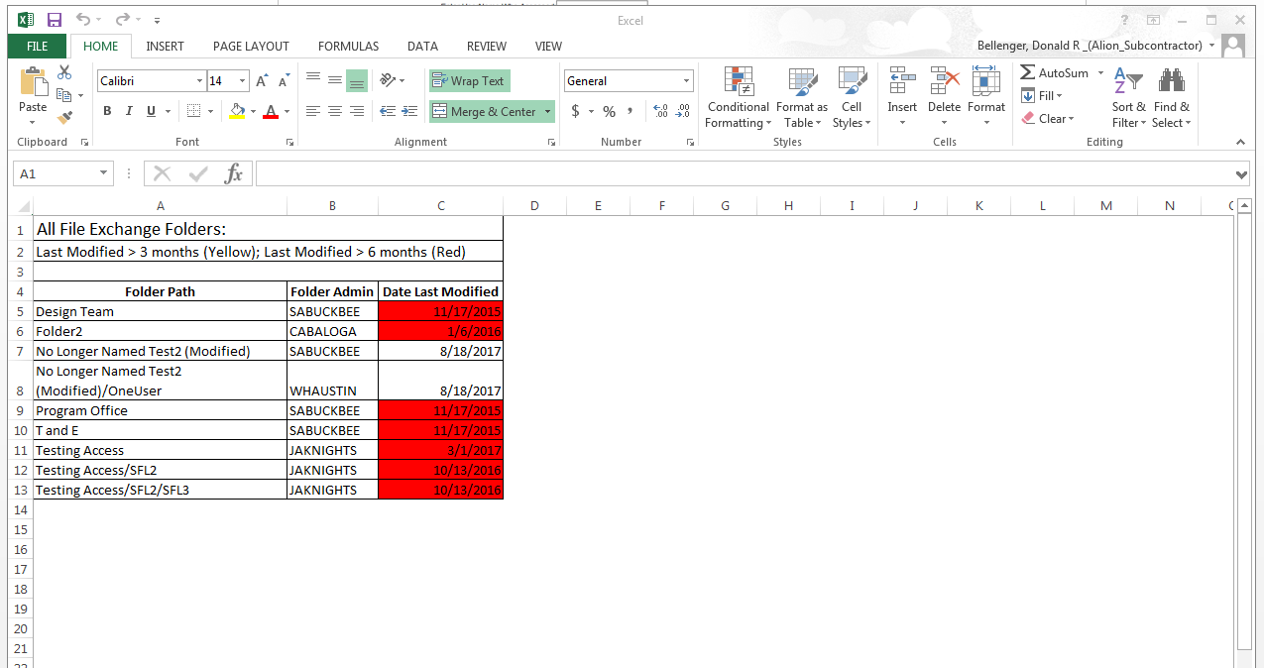

## Report – No Access

This is another spreadsheet. Note the total at the bottom.

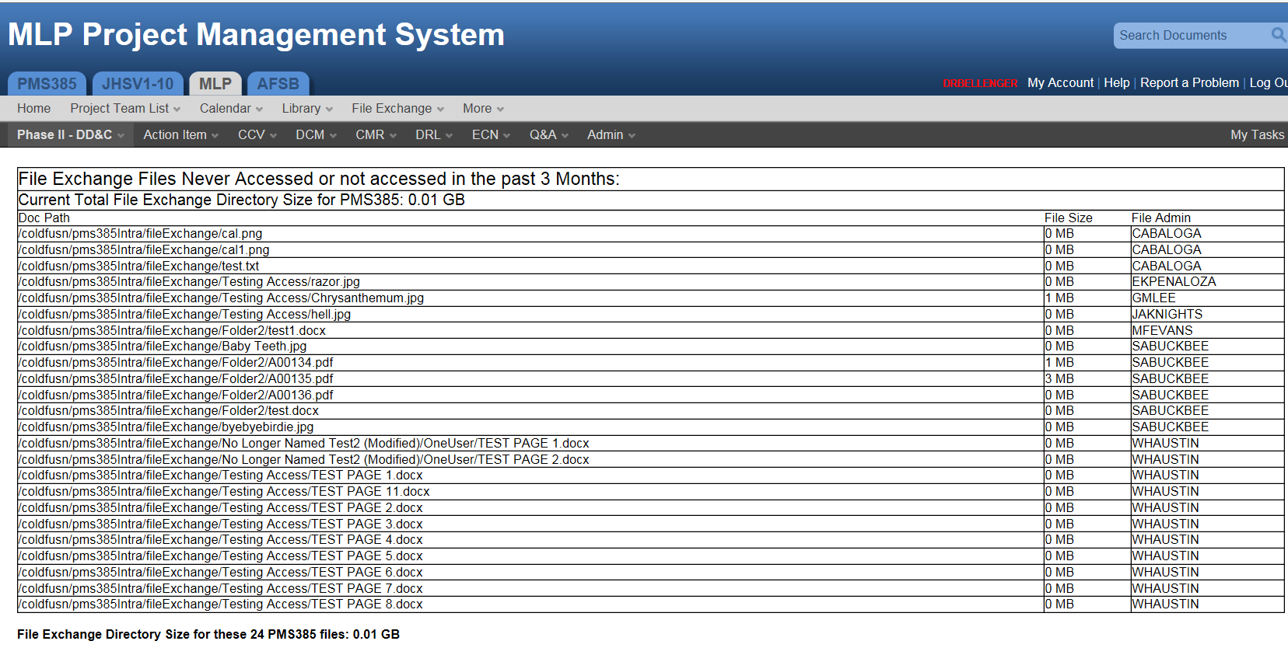

# Library

## Introduction

Although at first one might think that Library and File Exchange are similar, there are so many differences that we will discuss the Library Module independent from the discussion of the File Exchange module, above. These areas give an overview of Library: Library Content, Overall PMS-ES User Characteristics, and User Access to Library Content.

The discussion in this introduction is for the next generation (NG) library. For the convenience of programmers, we are also including some database table names in parentheses, where the particular relationships are maintained.

### Library Content

A PMS-ES Library contains **Folders, Documents, Collections, Versions, and Files**. **Folders** and **Files** are exactly analogous to Windows Folders and Files, and therefore analogous to File Exchange Folders and Files. Folders can contain files, and/or other folders. Library Folders historically have been called **Library Categories**. Currently there is no metadata for a Library Category to optimize searching. The folder has a title used in searching.

Files are only visible in the Library Module as Versions, within **Documents**. The simplest Library Document has one Version, which relates to one File, plus **metadata**. A Document must be in exactly one Folder, just like a Windows file is in exactly one Windows Folder. A **Collection** is a type of **Document** that contains more than one Document within it. A Collection is like a .zip file in Windows. If a Document within a Collection meets the criteria for a search, it is the Collection Title that shows in the result, not the Document Title. A Document, or each Document in a Collection, can have multiple **Versions**. Each version has one file. There is limited metadata for each File. To get a sense of how these relate, refer to the screen shots later in this chapter.

### Overall PMS-ES User Characteristics

PMS-ES users generally have roles and permissions for various project/phases (PROJSETTINGS). A project/phase is within a Program/Project hierarchy (PMSESPROJ_LU). The highest level of a project hierarchy is a program. A library is defined at the Program level (LBPROGLIBRARY). There are special roles that are NOT within program/project/phases. These include System Administrator, and Tester. These latter roles have privileges that are across all program/project/phases.

Users also are associated with COG codes, which is generally an organization code (USERSCOGCODE). A COG code is NOT part of a hierarchy. Cog codes are classified by ACTCODE and DIVCODE in a flat file - COGCODE_LU, which has all the fields). A user is NOT associated with an ACTCODE or a DIVCODE – only with a COGCODE.

A user can navigate to a program level (e.g. PMS325), or down to a project level (e.g. T-AO(X)).

### Visibility of Library Content

These rules are different from those for File Exchange.

A Collection/Document can be marked for visibility as follows.

* Visible to a list of Projects (not phases) within the Program associated with the Library. For example, if it is visible to PMS385/JHSV, it is visible to PMS385 for JHSV account holders, but NOT visible to PMS385/AFSB. The phase “for JHSV holders” means that, if a document is uploaded is access-marked for the JHSV Project, it is not visible to users without access to the JHSV Project. Remember that the Program/Project hierarchy is different from the folder structure in the library.
* Visibility to a list of COG codes. Note there is a convenience in the user interface (UI) to mark COG codes by Government Only, Government Support Contractor, and Shipyard. But after using one of the three convenience checkboxes, individual COG Codes can be set/unset.
* Visibility can be denied to specific users by name.
* If a Collection is visible to a user, then all of its Documents are visible.
* If a Document is visible to a user, then all of its versions are visible.
* There is no explicit marking of Folders for visibility. Instead, PMS-ES calculates folder visibility for the user on the fly. Currently, a folder is visible if there is any document/collection in the folder or subfolders that is visible to the user. (Calculating this on the fly is a big performance hit. **We may want to change this, or at least calculation folder permissions in the background).**

### User Access to Library Content

Only users with these roles can create a new Folder within the Library: SYSTEM ADMINISTRATOR, TESTER, LIBRARY ADMINISTRATOR.

Only users with these roles can add, change, or delete Documents within the Library: SYSTEM ADMINISTRATOR, TESTER, LIBRARY ADMINISTRATOR, LIBRARIAN.

Only users with these roles can view Documents in a Library: SYSTEM ADMINISTRATOR, TESTER, LIBRARY ADMINISTRATOR, LIBRARIAN, LIBRARY USER.

These are the specific rules of which users can see Documents in a Library.

|  |  |
| --- | --- |
| **Access to Documents from User Roles** | |
|  |  |
| **USER ROLE (PG = Privilege Group)** | **PERMISSIONS** |
|  |  |
| SYSTEM ADMINISTRATOR | Can see anything in any library |
| TESTER | Can see anything in any library |
| LIBRARY ADMINISTRATOR | Can see anything in a library where he/she is a library administrator |
| LIBRARIAN | Can see anything in a library where he/she is a librarian |
| LIBRARY USER | Must be in one or more Program/Projects that can view the document. Note: a user in PMS385/AFSB is NOT automatically in PMS385 |
| AND must be in one or more COG codes that can view the document. |
| AND must NOT be in the list of users specifically denied access to the document |

We will continue to support the “Search Document” capability in the following screenshot.

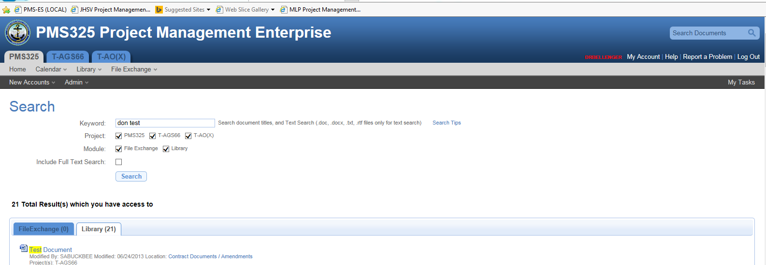

This searches File Exchange and Library titles, and performs a full text search on the content of .doc, .docx, .txt, and .rtf files.

## Browsing

When browsing the Library, you see folders in the folder hierarchy. The right side of the Browse screen can contain **Subfolders** and/or **Documents**. (Remember that a Collection is just a type of Document). A subfolder is simply a folder within another folder. A folder is analogous to a folder in Windows explorer. A folder has exactly one parent folder.

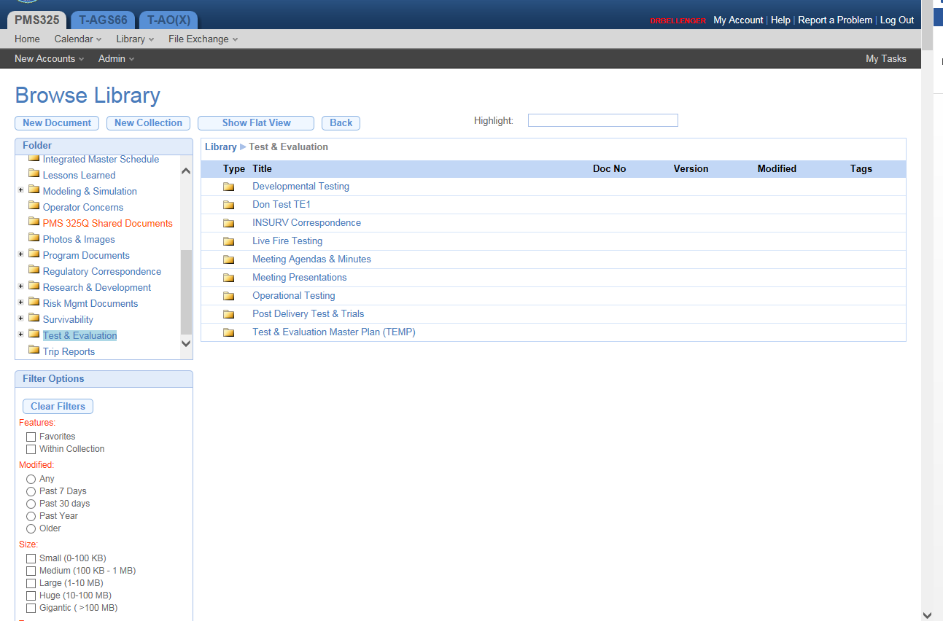

For example, clicking on the DonTestTE1 folder, we drill down to its content. There is a single item – a collection – Don Test Col 12. The version information entered at the collection level is DonVer2, and the collection is tagged with two tags: DONTAG1 and DONTAG2. Note that the breadcrumb trail is showing how you have navigated, showing the folder hierarchy.

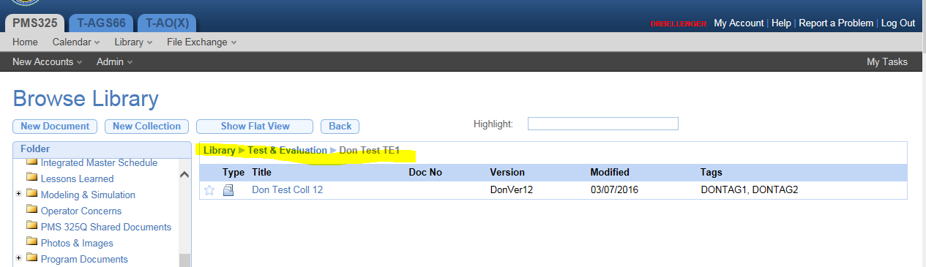

Clicking on Don Test Coll 12, you see details about the collection. The Assigned Access rights are for the collection. There are 4 documents. Each document can have its own version history. Each document may have different metadata (Originator, Classification, tags, etc.). The screenshot below shows the version history for the document: Don Test Doc 12-3.

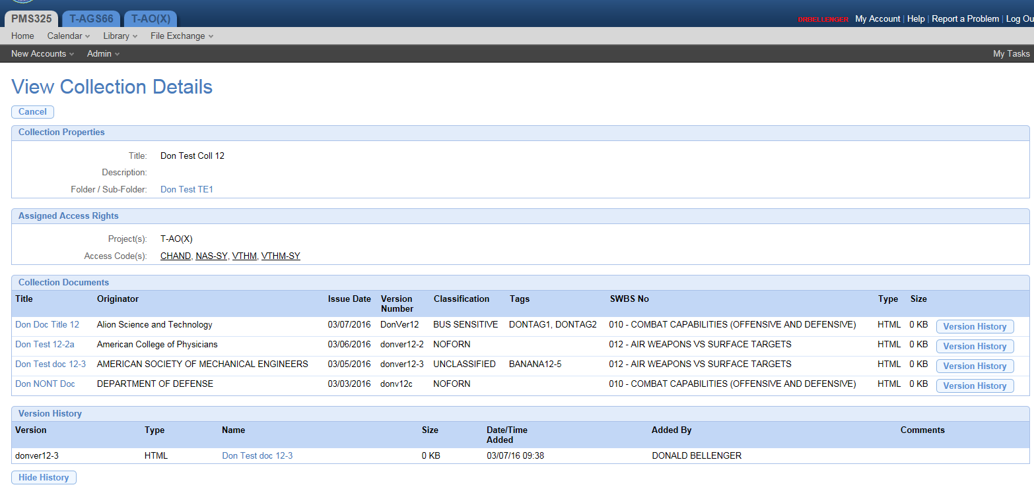

Clicking on the document Name or Title gives you a chance to open, download (save), or download and save the document.

Note that each version of a document is a **File**, in the File Exchange sense. That is, it is analogous to a file in Windows. A File is in exactly one Folder, which is the same folder in which the Collection resides.

The permissions model for Folders and Documents is the same in Library as in File Exchange. Access is granted to folders, documents, and collections based on a user’s association with a Project or a COG, having a certain Role, or having been specifically given permission to access the folder, document, or collection.

## Search and Edit

In order to see how to add, change, and delete documents and versions within a collections, you must use the Search Library Screen. Here is a search that will find the same Don Test Coll 12 collection we have been viewing. The search is based on metadata, folder structure, and permissions. Importantly, clicking on an arrow that appears when you hover over the Collection titles offers options to

* View properties – this is what we have seen above
* Edit Collection Properties
* Manage Versions
* Delete Collection

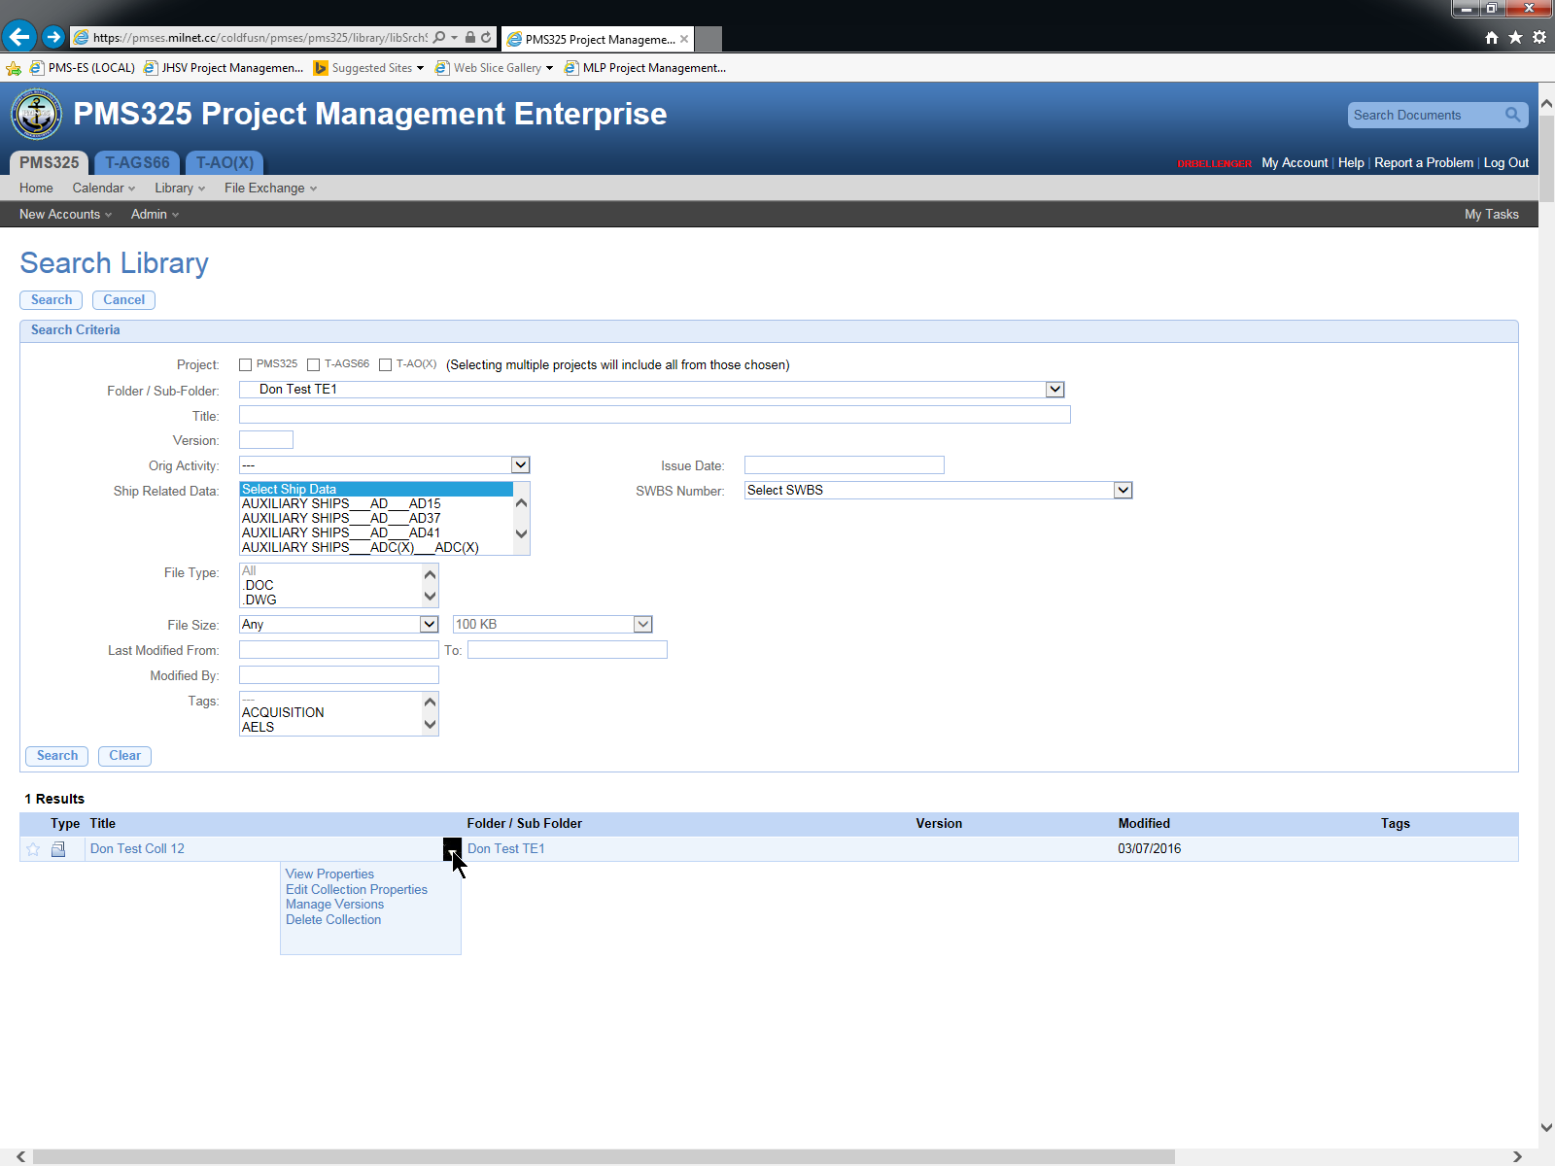

## Edit Collection Properties

Clicking Edit Collection Properties above yields this screen:

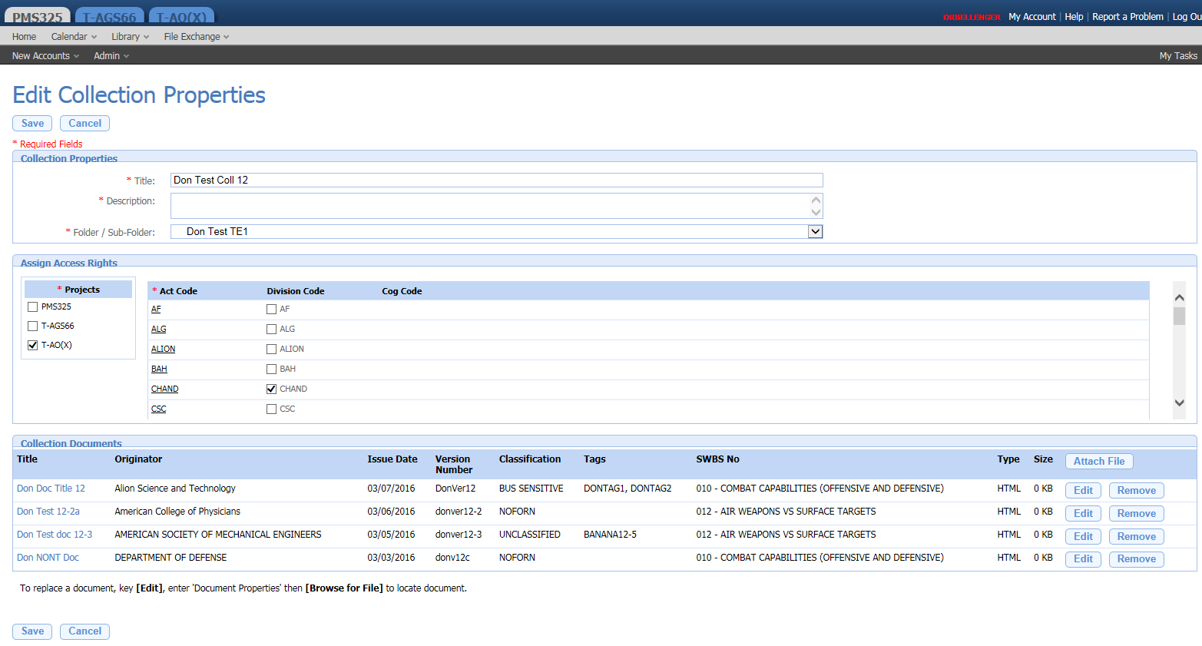

This comprehensive screen allows changing the Title, Description, the location of the collection within the Folder Structure, changing access rights to the collection Adding a new File to the Collection, Editing an existing file (including adding a new version to a file), or removing a file. It does not allow changing the metadata for the collection.

Clicking Edit on one of the Document Lines allows you to change the metadata for that Document!!! (This is not the same as the metadata for the collection). You may also upload a replacement file for that document. Note that a document within a collection is always a single file.

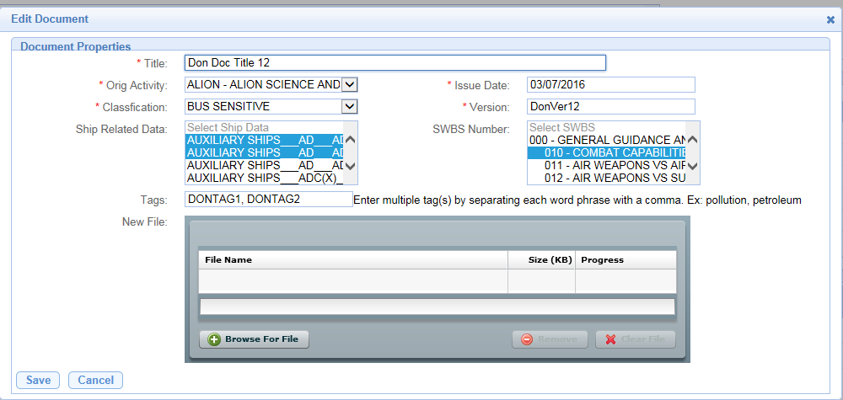

Clicking Remove immediately deletes the document (file) from the collection.

Clicking Attach File within the Document Section at the bottom goes to the Edit Collection Properties screen shown above, with the addition of a panel for uploading a new Document (file) into the collection.

## Attach Document

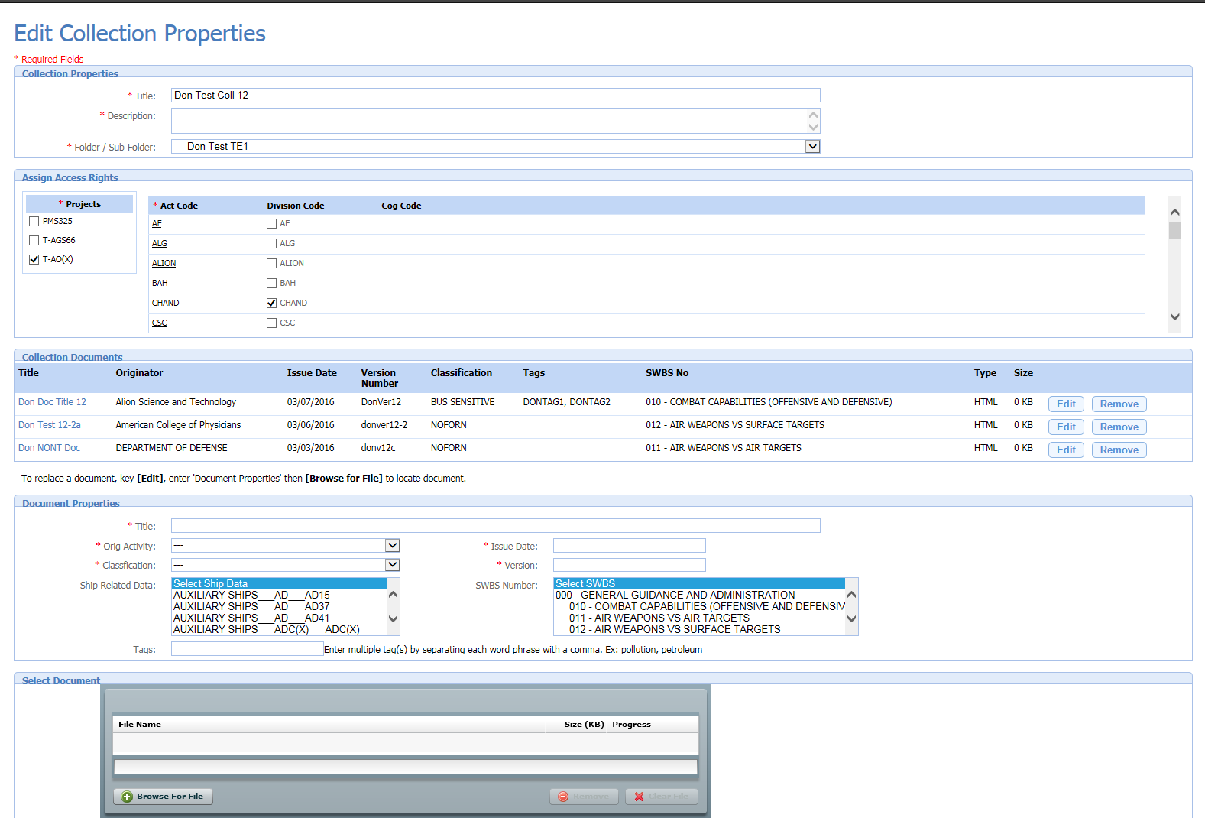

Again, you cannot change most of the metadata for the collection on this screen. You may change the collection title, description, and location within the folder hierarchy. You can change the Access Rights for the new document (not the collection). You can upload a file for the new document you are attaching. Here is an example. Note how unrelated the Document properties are to the original collection.

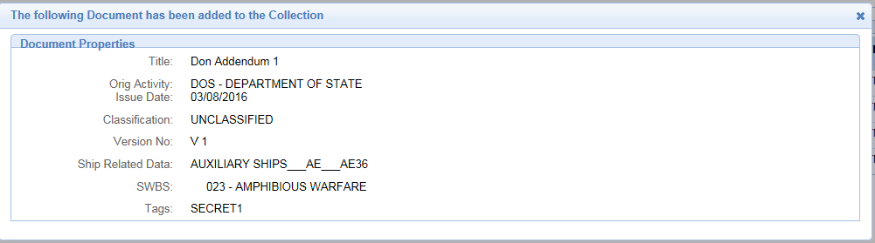

## Guidelines when developing new Library

How do we handle the differences between Read Access and Read/Write Access?

How does the existing security model handle this?

Right now, Browse lets you view information, while Search lets you edit documents. Is that what we want?

Should we explicitly prevent creating a document that is visible to a particular COG in a folder that is NOT visible to the same COG? Same for projects, users, and

## Here are some old database notes

The fundamental item in the Library is a **document**. However, a document is made up of one or more files. This is similar to a **file** in File Exchange, except that there is substantial “metadata” associated with a document. Because displaying and entering this metadata requires window space in the UI, there functions of Browse and Search that are on one screen in File Exchange, appear in two screens in Library. A library document resides in the LIBDOCS table. The key field is NOT the expected LIBDOCSID. Instead, it is LIBDOCSSEGID. This is because a file can be broken up into segments. This is only done for very large documents. On the other hand, there is an index on LIBDOCSID, which will be almost always the index that is used.

A document is in one project/phase (reflected in a particular PROJSETTINGS record). There is a LIBDOCPROJ record where LIBDOCPROJ.LIBDOCSID and LIBDOCPROJ.PROJSETTINGSID puts it there. Note that a particular PROJSETTINGS record is related to a project through PROJSETTINGS.PROJID, that that the PROJSETTINGS record puts the document in the project hierarchy

A **collection** appears in Library, but not in File Exchange. A collection is a group of documents that is tied together under a single name, similar to a zip file in Windows. The documents in a collection can be in different folders ???????. The documents in a collection can have differences in their security selections. Once a collection has been created, its constituent files cannot be deleted, nor may new files be added to a collection ?????.

A **folder** in Library is referred to in the Library Module User Interface as “Folder/Sub-folder”. Information about a library folder is stored in the LIBDOCCATEGORY table. There is an entry in the LIBDOCCATEGORY table for each folder in library. The key field is LIBDOCCATID. LIBDOCCATEGORY is analogous to FEFOLDERS in FileExchange, with very important differences.

FEFOLDERS.PARENT_FOLDER_ID reflects the folder hierarchy in FileExchange. There is no similar mechanism in Library! Instead, LIBDOCCATEGORY.SORTORDER is used to control display of a folder “under” another folder. However, this approach is substantially less efficient when performing queries for particular subsets of library documents, based on location in folders.

LIBDOCCATEGORY.PROGRAMID is OBSOLETE??? It is always 1.

A library folder is in a project/phase (PROJSETTINGS) if there exists a LIBDOCCATPROJ record where LIBDOCCATPROJ.LIBDOCCATID and LIBDOCCATPROJ.PROJSETTINGSID put it there.

The library folder can then be related to the project hierarchy through the relationship from PROJSETTING.

A User must have the Role of LIBRARY USER to access the library. A LIBRARIAN can do everything that a LIBRARY USER can do, and more, including creating folders.

In addition, there is a Library Home screen, which shows the logged in user a quick overview of his Library activity. So the main screens are

* Search
* Browse
* Home

## Library Search Screen

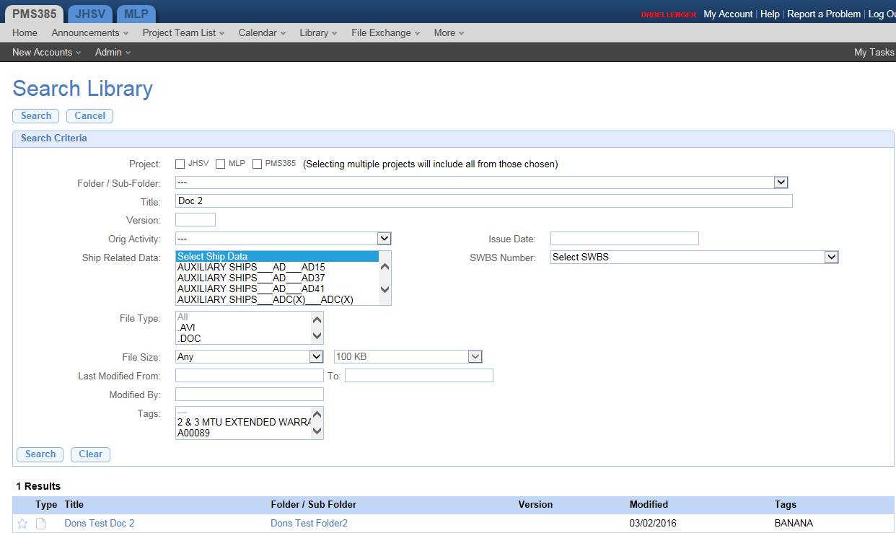

Here is another view of the Library, using the Library Search screen. The search allows you to find a folder or a document, based on project, parent folder, partial match on title, version, and so forth, down through Tags.

The **metadata** is the Project, Folder / Sub-Folder, Title, etc.

The higher number of fields in the metadata than in File Exchange offers a higher degree of granularity of the search than in File Exchange.

You can search on folder/subfolder, and title, from this one screen.

A search for “BANANA” in the tag list would yield the same document. Note that BANANA is added to the dropdown list of tags when that tag is added to any document.

On the other hand, the File Type dropdown is not augmented with say, .CFM, when uploading a .cfm file.

The screen shows the result of searching for “Doc 2” in the title. Note that this is a partial search, and Doc 2 does not appear at the beginning of the title.

Clicking on the Folder sends you to Library Browse, having navigated to the particular folder.

Clicking on the Title allows you to goes to the View Document Details screen.

## Library View Document Details Screen and Open/Download File

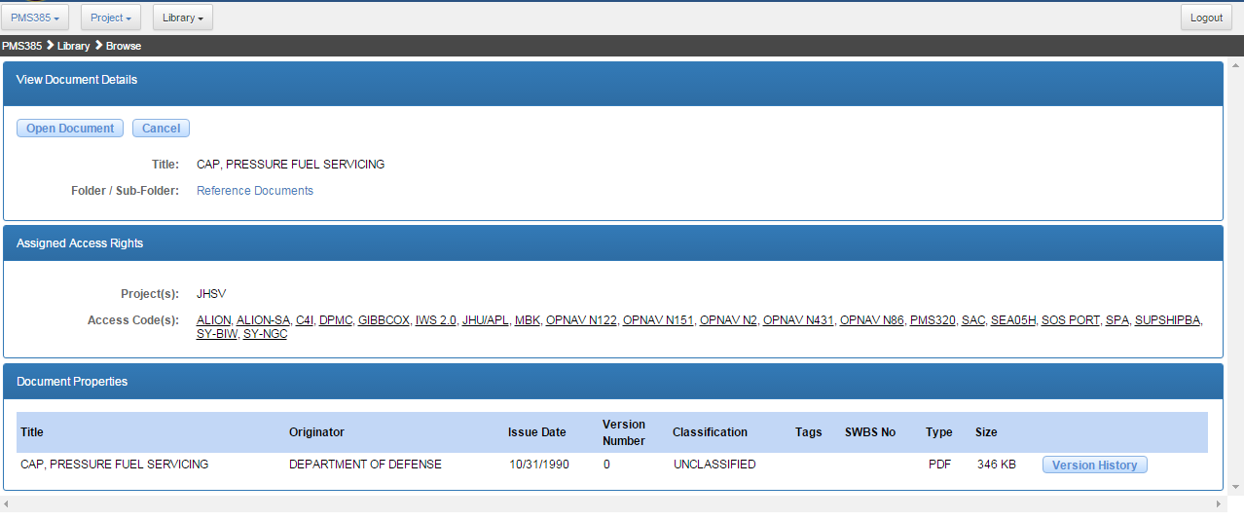

The View Document Details screen, which allows you to

* View (not edit)

1. Version History
2. Document Properties
3. Assigned Access Rights

* Delete Document
* Manage Document Properties
* Manage Document Versions – this sends you to the Library New Version Screen, from which you can upload a file.
* Open or Download a file by clicking on Open Document, or on the Document Title.

## Library Home Screen

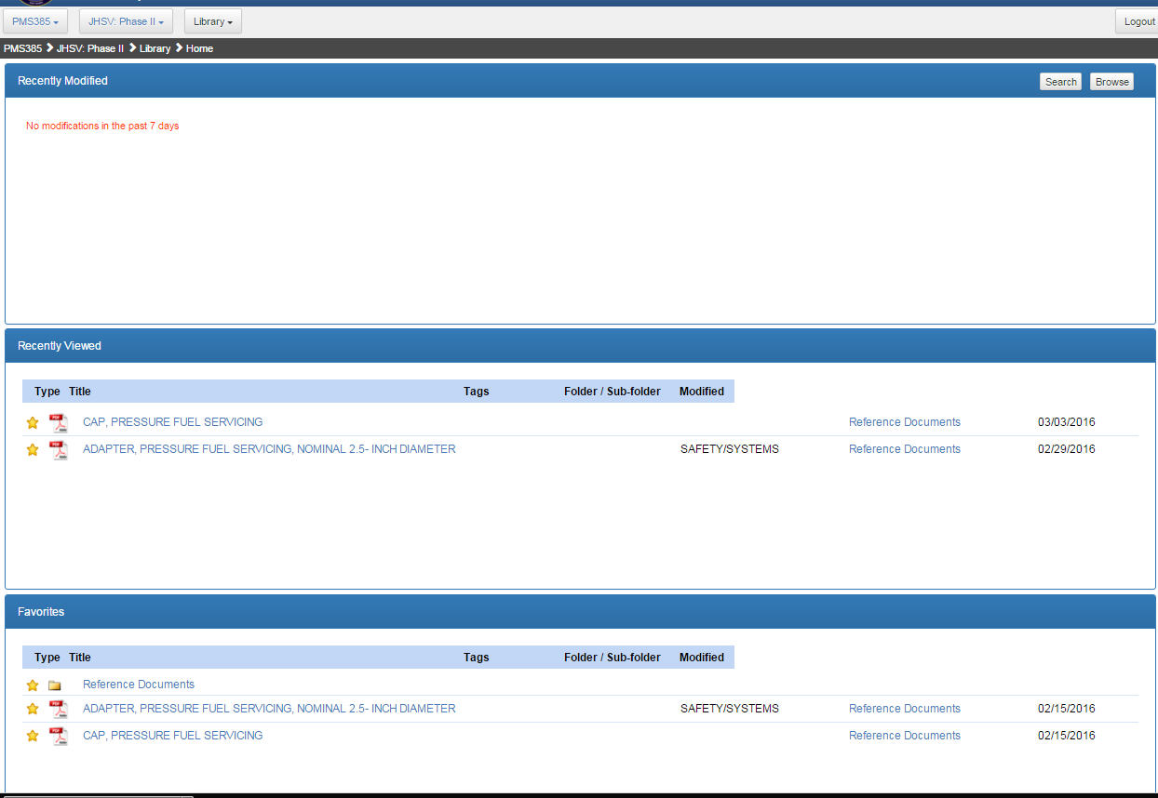

The Library Home screen shows the documents that were most recently modified, the documents most recently viewed, and the ones selected as favorites by the logged in user.

Clicking on a document title brings you to the Library View Document Details Screen

Clicking on a Folder/Sub-folder brings you to the Library Browse Screen

## Library Browse Screen

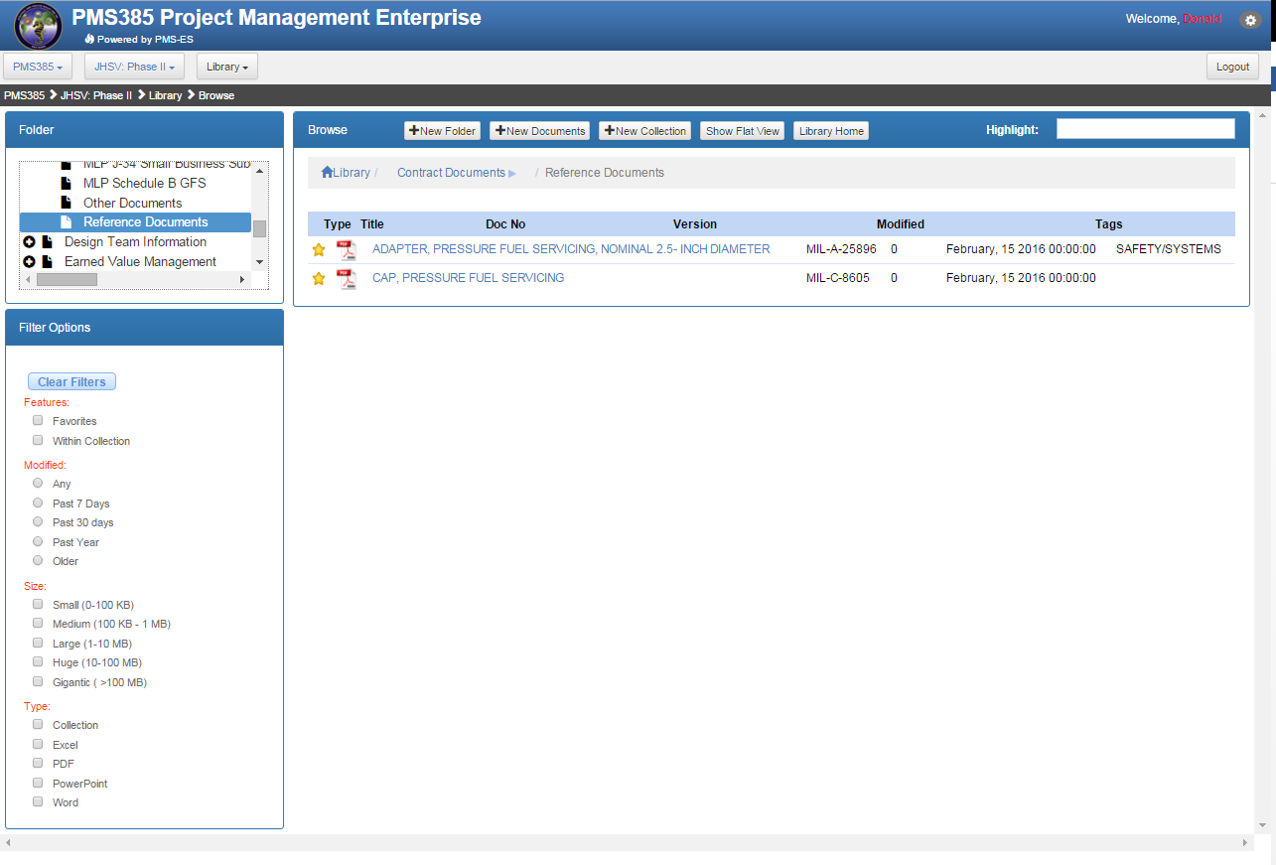

The Library Browse screen has a Folder Tree at the Top Left.

The Filter Options panel at the bottom left supports check boxes to filter the items that appear on the right.

There is a “breadcrumb” area to indicate where you are in the navigation. This is similar to the information you might receive by looking at the tree in the top left panel.

The right hand panel shows folders and/or documents.

Clicking on a document title brings you to the View Document Details screen.

## Library Add New Document Screen and Upload File

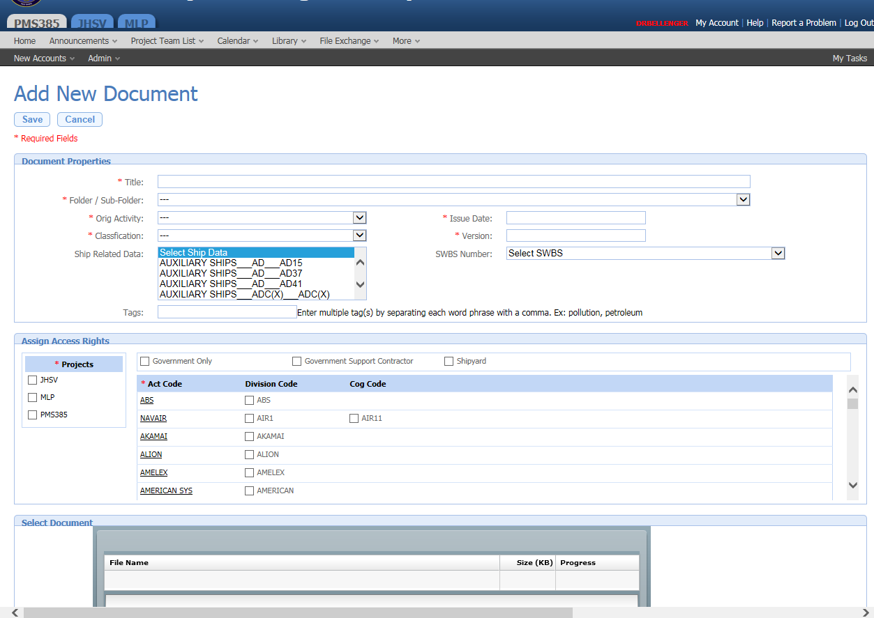

## Library New Version Screen and Upload File

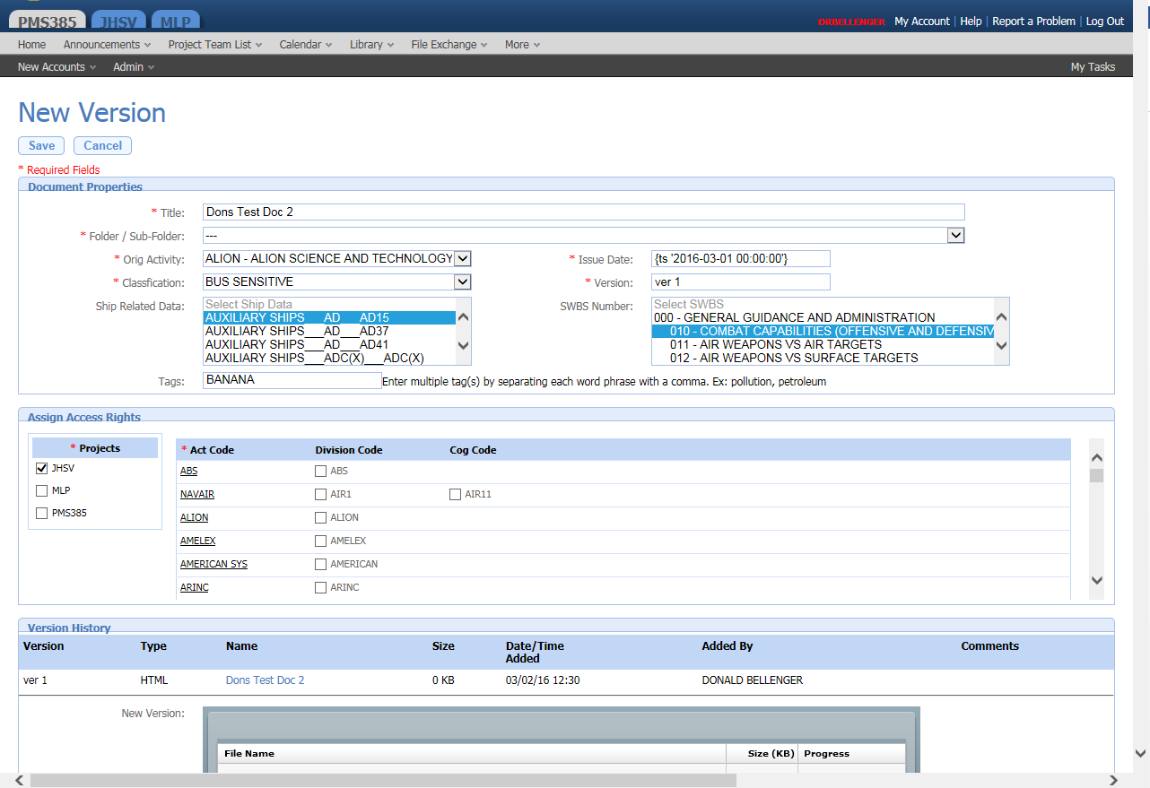

This allows entering all the Metadata, modifying the Assign Access Rights, and uploading a version of the file.

# Calendar

# Announcements

# Project Team Maintenance

# Central Management Console

# InfoView (AdHoc Reporting)